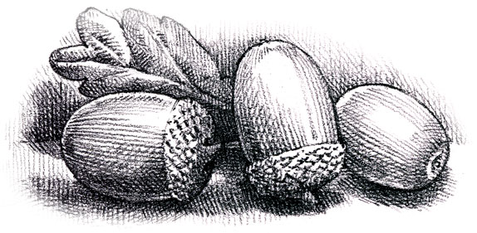
Dunford Parish Council

Agenda for the meeting to be held on
Thursday 16th March 2023 at 6.30 p.m.
at The Parish Community Centre

PLEASE NOTE: THIS MEETING WILL BE FOLLOWED BY THE ANNUAL ASSEMBLY

- Minutes of the meeting held on 19th January 2023

- Matters arising
Defibrillator
Replacement bus shelters - quotation

- Dunford Residents Association – update

- Melonie Parkin memorial seat

- A616 Hazlehead crossroads – speed limit
Victoria crossroads

- Planning Applications

- Finance
Monthly accounts
Bank update

- Any other business

- Date and time of next meeting:
18th May 2023 at 6.30 p.m. at the Parish Community Centre. This will be the first meeting of the Council following the local elections.

