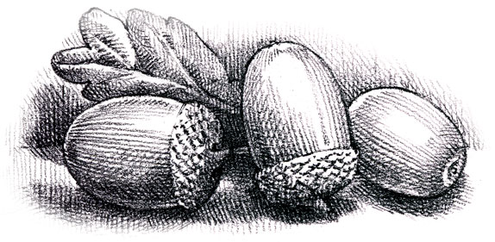
Dunford Parish Council

Agenda for the meeting to be held on
Thursday 19th May 2022 at 6.30 p.m.
at The Parish Community Centre

- Appointment of Chair

- Appointment of Vice-Chair

- Minutes of the meeting held on 17th March 2022.

- Appointment of officers for 2022/23 (2020 appointments for information)
YLCA: Cllrs A. Pestell and T. Singleton
PPPF: Cllrs A. Pestell and T. Singleton
CPRE: Cllr A. Pestell
Infinis: Cllrs A. Whitehead/A. Pestell
Banks: Cllrs N. Armitage /A. Pestell

- Annual Assembly and AGM 2021/22

- Crowedge Play Area

- Planning Applications

- Finance
Accounts 2021/22 and end of financial year balances

- Correspondence

- Any other business

- Date and time of next meeting:

Thursday 21st July at 6.30 p.m. at the Parish Community Centre,
Sheffield Road, Victoria HD9 7TP.

