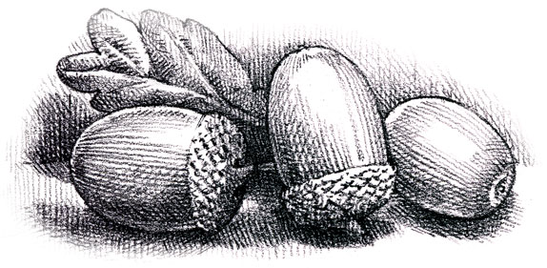
Dunford Parish Council

Agenda for the meeting to be held on
Thursday 15th September 2022 at 6.30 p.m.
at The Parish Community Centre

- Minutes of the meeting held on 21st July 2022

- Matters arising from the minutes

- Register of Interests - Annual update

- Crowedge Play Area

- Dunford Parish Community Association

- Finance

- Planning Applications

- Any other business

- Date and time of next meeting:
15th September 2022 at 6.30 p.m. at the Parish Community Centre

