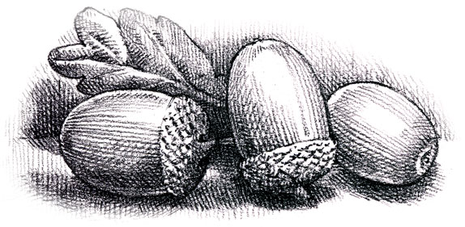
Dunford Parish Council

Agenda for the meeting to be held on
Thursday 17th March 2022 at 6.30 p.m.
at The Parish Community Centre

- Minutes of the meeting held on 20th January 2021.

- Crowedge Play Area

- Finance

- Planning Applications

- Any other business

- Date and time of next meeting:
19th May 2022 at 6.30 p.m. at the Parish Community Centre

