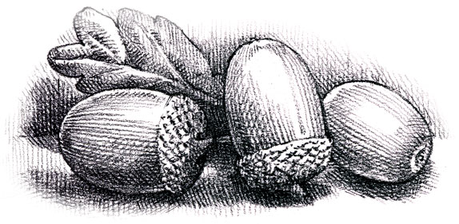

Agenda for the meeting to be held on
Thursday 9th May 2019 at 7.30 p.m.
at The Parish Community Centre

- Appointment of Chair

- Appointment of Vice-Chair

- Appointment of officers for 2019/20 (previous year’s appointments for information)
YLCA: Cllrs A. Pestell and T. Singleton
PPPF: Cllrs A. Pestell and T. Singleton
CPRE: Cllr A. Pestell
Infinis: Cllrs A. Whitehead/A. Pestell
Banks: Cllrs N. Armitage /A. Pestell

- Minutes of the meeting and Annual Assembly held on 14th March 2019

- Matters Arising

- DPCA/DPC – future arrangements

- Website/Facebook Page(s)

- Crowedge Play Area

- Planning Applications

- Finance
Annual Governance Statement
Accounts 2018/19

- Correspondence

- Any other business

- Date and time of next meeting:
Thursday 11th July at 7.30 p.m. at the Parish Community Centre,
Sheffield Road, Victoria HD9 7TP.

